**Lab 5 – Ben Joye**

**9/20/18**

**Requirements Analysis:**

**Functional:**

* As a user, I must be able to able to input which implementation to use so that the right constructor is called.
* As a user, I should be able to keep choosing functions so that the program doesn’t end until I input 8.
* As a user, I must be able to input 1-7 so that I can add, get next, peek at front, peek at back, insert, get, and remove from the queue.

**Non-Functional:**

* Both implementations must have an add function.
* Both implementations must have a pop function that returns the first value in the list.
* Both implementations must have a function that returns the size of the list.
* The system must be able to handle a list of up to 100 values.
* The system must print list in the correct order to the console.
* The program must be written in java.
* The program must run on unix.

**Design:**

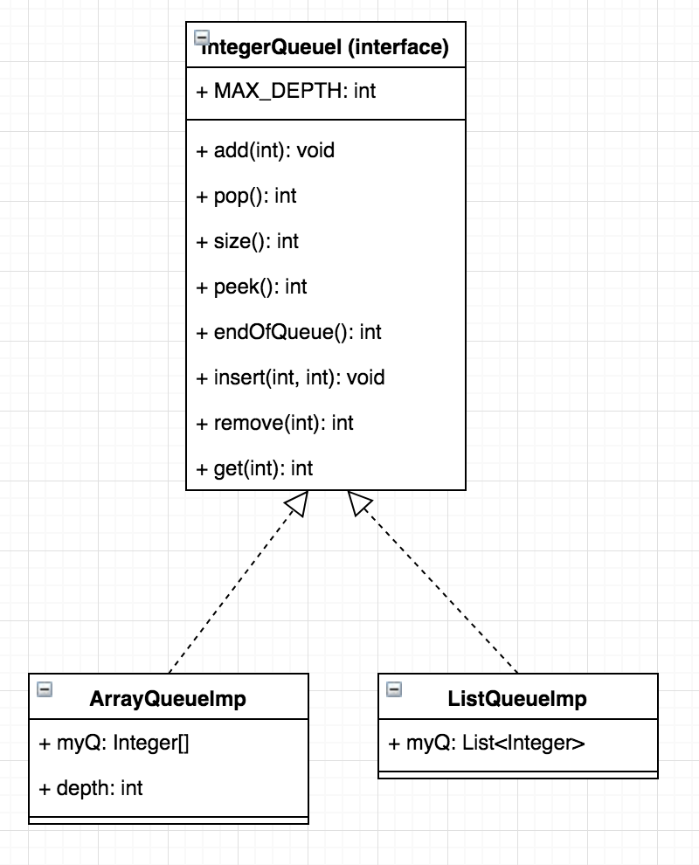

**Testing:**

* Both the list and array implementations work identically
* If you try 1,2,3,4,7, they will not run when the queue is empty
* You can only get and remove positions that exist
* Input 8 ends the program

**Deployment:**

* On unix:
  + Compile: “make”
  + Run: “make run”